Utilizing the QR Code to Track Attendance
The QR code will be the most effective way to track attendance during your event. This method is digital and any student who scans the code will automatically be added to the event’s roster. The QR code is automatically generated for your event and can be displayed multiple ways for students to access.

Accessing the QR Code
To access the QR code, view your event’s page and click on Manage Event in the top right corner (Figure 1).
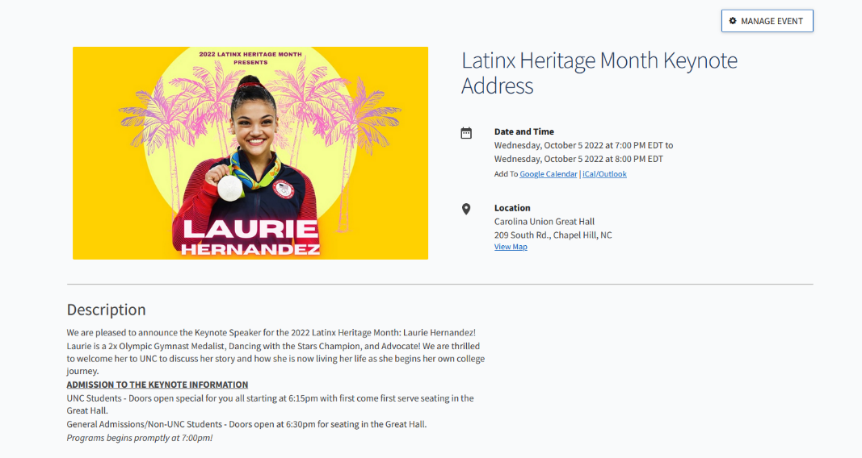
Figure 1
This will be the admin view for your event. Here, you can make changes to your event and manage the attendance. Nex to Attendance URL will be a button to View QR Code (Figure 2). 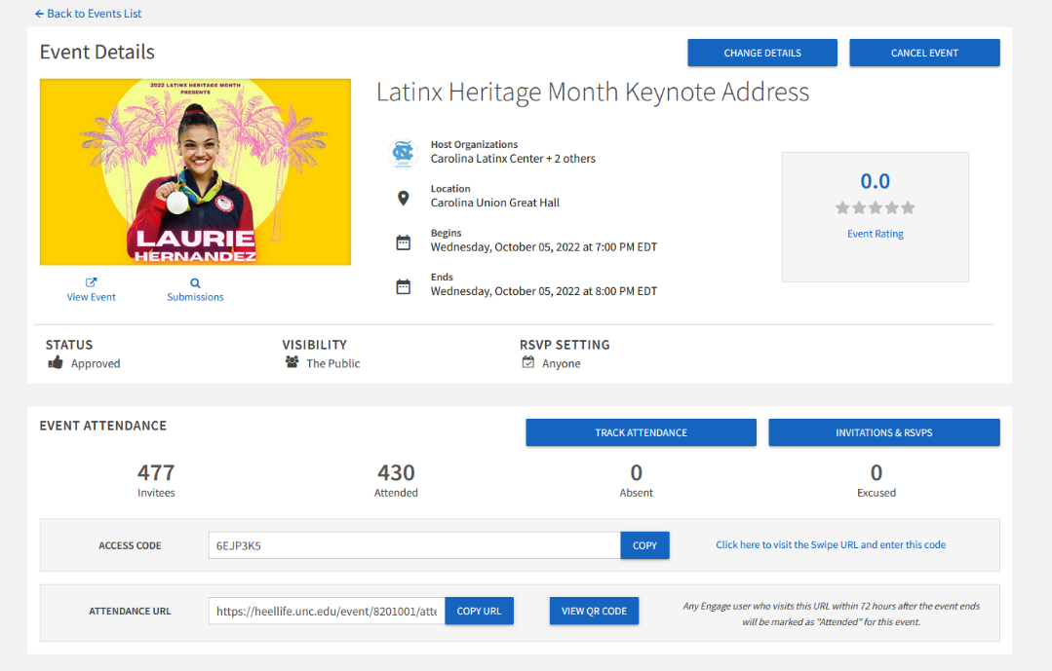
Figure 2
This QR code is automatically generated for your event and can be added to presentations, a physical flyer, or other media. The QR code can be saved as PNG Image or can be copied to your clipboard for quick access pasting (Figure 3).
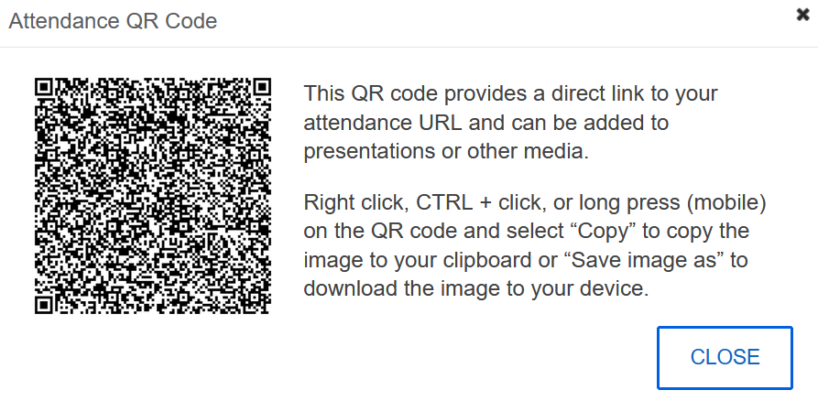
Figure 3

QR Code Flyer Template
The QR code can be used as a flyer to display at your event or uploaded to a display monitor if available. This template may be used if you would like to have a QR Flyer. Insert or paste the image then right click on the image and set warp text to in front of text to freely move the QR code between the text and CLE logo. Resize as needed (See next page).

ATTENDANCE CHECK-IN

Questions? Email: CLE@unc.edu
To find more CLE events: go.unc.edu/CLE
Visit our website for more information and FAQs: go.unc.edu/CampusLifeExperience

